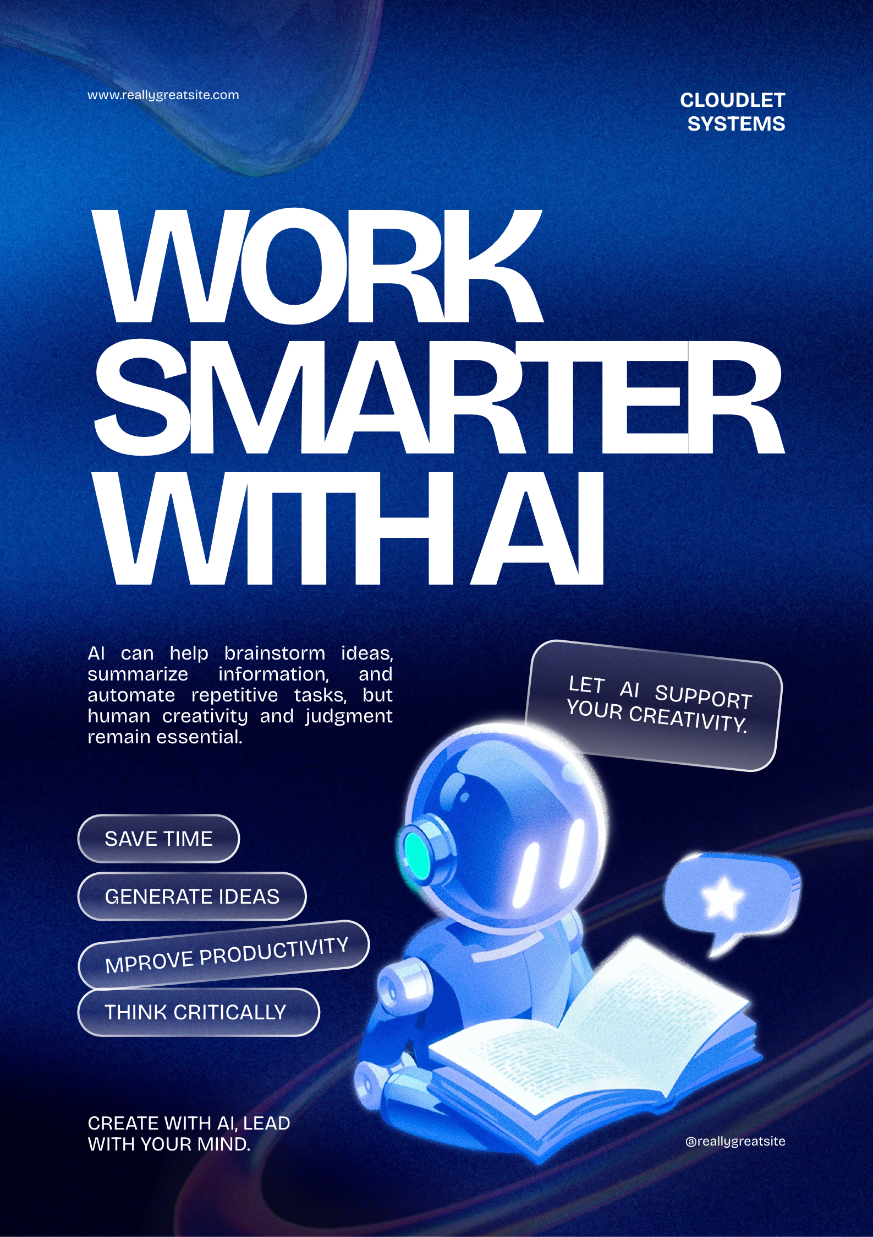
Create a poster using Canva or Figma with AI-generated content.
Generated using Canva

